**Web Site Development**

**Week 1 Content:**

CHAPTER 2- New for HTML5 …………………………………………………………………………………………...……………………. 2

2.1- What’s Different in HTML5?

2.3- <!DOCTYPE> in HTML5

CHAPTER 3- Designing a Webpage………………………………………………………………………………………………………….3

3.1- Design Considerations and Planning

3.2- Basic Tags and Document Structure

3.3- HTML tags <HTML>…</HTML>

3.4- Head Tags <HEAD>…</HEAD>

3.5- Title Tags <TITLE>…</TITLE>

3.6- Body Tags <BODY>…</BODY>

3.7- Metadata

3.8- Saving an HTML Page

CHAPTER 4- Page Formatting…………………………………………………………………………………………………………………9

4.1- Adding a New Paragraph

4.2- Adding a Line Break

4.3- Inserting Blank Space

4.4- Preformatted Text

4.5- Changing a Page’s Background Color

4.6- Div Element

CHAPTER 5- Text Items and Objects………………………………………………………………………………………....…………..14

5.1- Headings

5.2- Comments

5.3- Block Quotes

5.4- Horizontal Lines

5.5- Special Characters

Text Items and Objects- Actions

Text Items and Objects- Exercises

CHAPTER 6- Creating Lists……………………………………………………………………………………………………….………….21

6.1- Numbered (Ordered) Lists

6.2- Bulleted (Unordered) Lists

6.3- Nested Lists

6.4- Definition Lists

Creating Lists- Actions

CHAPTER 7- Links …………………………………………………………………………………………………………………………… 24

7.1- What are Links?

7.2- Text Links

7.3- Image Links

7.4- Opening a Page in a New Window or Tab

7.5- Setting All Links on a Page to Open in a New Window or Tab

7.6- Linking to an Area on the Same Page (Bookmarks)

7.7- Linking to an E-mal Address

7.8- Linking to Other Types of Files

Links- Actions

Link Exercises

CHAPTER 8- Images…………………………………………………………………….………………………………….…...…………….33

8.1- Introduction to Images for Webpages

8.2- Adding Images to Webpages

8.3- Re-Sizing an Image

8.4- Alternative (ALT) Text

8.5- Image Labels

Images- Actions

Image Exercises

CHAPTER 2- New for HTML5

**2.1 - What Makes HTML5 Different:**

HTML5 brings numerous improvements that simplify web development. It offers clearer and more straightforward semantics and structure compared to previous HTML versions. New elements have been introduced, and redundant tags have been eliminated. Media integration has been optimized for various platforms, including desktop computers, tablets, and mobile phones. Detailed coverage of these new additions will be provided in upcoming chapters of this course.

Importantly, for those transitioning from HTML4 to HTML5, it's essential to be aware that certain tags are no longer supported in HTML5. Using these unsupported tags may lead to errors or unintended webpage appearance. We strongly recommend reviewing your existing code and replacing or removing the following tags:

<acronym>, <applet>, <basefont>, <big>, <center>, <dir>, <font>, <frame>, <frameset>, <noframes>, <strike>, <tt>

**2.2 - <!DOCTYPE> in HTML5:**

The <!DOCTYPE> declaration in HTML5 is not a typical "tag." Instead, it functions as a statement to inform the browser about the HTML version used in your code. It's a mandatory element and should precede the <html> tag in every web page you create. Notably, <!DOCTYPE> is case-insensitive and does not require an end tag. Your page's initial structure should appear as follows:

<!DOCTYPE html>

Following this declaration, you can add your HTML code.

CHAPTER 3- Designing a Webpage

**3.1 - Design Considerations and Planning:**

Before diving into web page design, it's crucial to have a clear vision of your desired end result. Consider sketching a rough layout on paper, indicating the placement of text, images, and other elements. This draft will serve as your blueprint throughout development, especially when designing an entire website with multiple pages.

Additionally, think about how to organize your pages for easy user access. Most websites include common pages such as the home page, contact page, and FAQ page. The home page usually offers a brief introduction to the entire site and often serves as the main entry point.

As you start, explore your favorite websites for inspiration. Observe their layouts, navigation, and design details. Analyze what makes them user-friendly and appealing. Create a visual flowchart of your site to provide a clear map for your work.

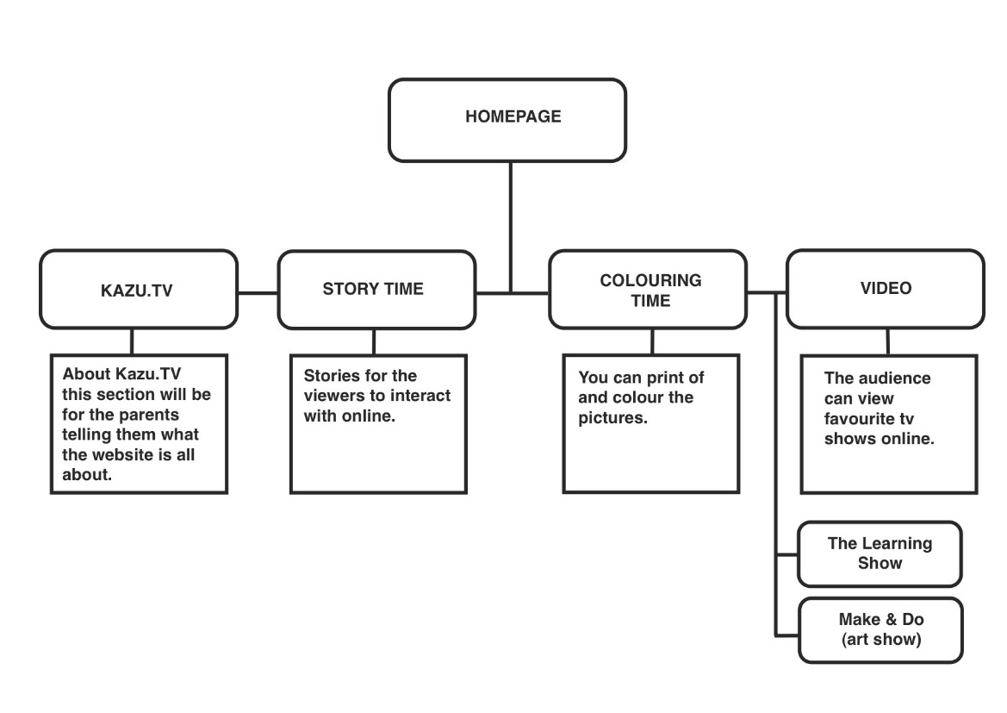

**3.2 - Basic Tags and Document Structure:**

Once you have a clear plan and layout in mind, it's time to start designing your HTML page. Regardless of content and layout variations, all HTML documents follow a basic structure and use foundational tags as building blocks. Every HTML page includes the following structural tags:

<!DOCTYPE html> | Declaration of the HTML version |

<html>...</html> | The main HTML container |

<head>...</head> | Container for document metadata |

<title>...</title> | Title of the webpage |

<body>...</body> | Main content of the webpage |

**3.3 - <HTML>...</HTML>:**

The <html> and </html> tags are fundamental, identifying your page as an HTML document. Every HTML page should start with <!DOCTYPE html>, <html>, and end with </html>.

|  |  |  |
| --- | --- | --- |
| Beginning of every  page: | <!DOCTYPE html> | Tells browser version of HTM |
| Start Tag: | <html> |  |
| End Tag: | </html> |  |
| Attributes: | None |  |
| Example: | (Start of HTML document)  <!DOCTYPE html>  <html>  </html>  (End of HTML document) | These tags must be the first  and last tags used in your  HTML document. |

**3.4 - <HEAD>...</HEAD>:**

The <head>...</head> tags define your document's header, containing essential information such as the title and metadata. These tags immediately follow the opening <html> tag.

|  |  |  |
| --- | --- | --- |
| Start Tag: | <head> |  |
| End Tag: | </head> |  |
| Attributes: | None |  |
| Example: | <!DOCTYPE html>  <html>  <head>  <title> Browser Title</title>  </head>  <body>  …  </body>  </html> | These tags define the heading  area of the document |

**3.5 - <TITLE>...</TITLE>:**

Title tags enable you to name your HTML page, which appears in the browser's title or tab bar. They also serve as the name when users bookmark your page.

|  |  |  |
| --- | --- | --- |
| Start Tag: | <title> |  |
| End Tag: | </title> |  |
| Attributes: | None |  |
| Example: | <!DOCTYPE html>  <html>  <head>  <title> TeachUcomp, Inc. Home Page</title>  </head>  <body>  …  </body>  </html> | These tags define the  information to be  displayed in a  browsers’ title bar. |

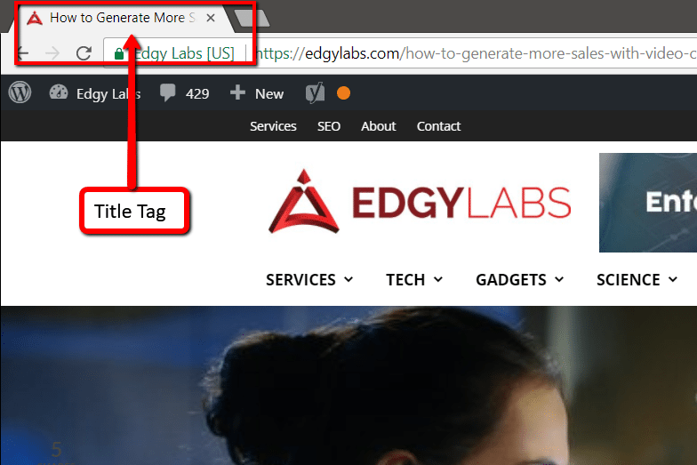

**3.6 - <BODY>...</BODY>:**

The <body>...</body> tags identify the area where all your webpage content resides. Any text, images, lists, tables, forms, or other elements go between these tags.

|  |  |  |
| --- | --- | --- |
| Start Tag: | <body> |  |
| End Tag: | </body> |  |
| Attributes: | text= | Specifies a default text color |
|  | link= | Specifies the default text color  used to identify a unvisited links. |
| Example: | <body>  …(Main browser window content)  </body> | These tags define information to  be displayed in the browser’s main  window. |

**3.7 - Metadata:**

Metadata includes details about your webpage, such as descriptions, keywords, and copyrights. While not visible on the webpage, search engines use metadata to rank pages in search results.

|  |  |  |
| --- | --- | --- |
| Tag: | <meta…> | Does not require a closing tag. |
| Attribute: | name= |  |
|  | author | Specifies the author of the HTML page. |
|  | description | Define a broad description of the HTML  page. |
|  | keywords | Identifies Keywords relevant to the  content of the HTML page. Used by  search engines to index and rank  pages. |
|  | copyright | Specifies copyright information. |
| Examples: | <meta name=author”  content=“John Smith”> | Identifies John Smith as the author of  this HTML page. |
|  | <meta name=“description”  content=“HTML Tutorial by  TeachUcomp, Inc.”> | Specifies the description of the HTML  page. |
|  | <meta name=“keywords”  content=“html tutorial, html  training, learn html”> | Specifies the keywords relevant to the  HTML page. |
|  | <meta name=“copyright”  content=“Copyright  TeachUcomp, Inc. 2014. All  rights reserved.”> | Specifies the copyright statement. |

**3.8 - Saving an HTML Page:**

If you're using advanced editors like Dreamweaver or CoffeeCup, your documents are typically saved as HTML pages by default. For simple text editors like Notepad or Wordpad, save your files as text documents with the .htm or .html extension. Avoid using blank spaces in file names, keep them concise and descriptive.

CHAPTER 4- Page Formatting

**4.1 - Adding a New Paragraph:**

In HTML, you create new paragraphs using `<p>...</p>` tags. Line breaks from word processors like Microsoft Word aren't recognized by web browsers.

|  |  |  |
| --- | --- | --- |
| Start Tag: | <p> |  |
| End Tag: | </p> |  |
| Attributes: | None |  |
| Example: | Welcome to Mastering HTML5 and CSS3 Made Easy  <p>This is how you create new paragraphs.</p>  <p>See how easy it is to do?</p> |  |
| Result: | Welcome to Mastering HTML5 and CSS3 Made Easy    This is how you create new paragraphs.  See how easy it is to do? |  |

**4.2 - Adding a Line Break:**

To insert line breaks, use the `<br>` tag, which doesn't require an end tag. Each `<br>` tag adds a new line.

|  |  |  |
| --- | --- | --- |
| Start Tag: | <br> |  |
| End Tag: | None |  |
| Attributes: | None |  |
| Example: | <p>This is where your fist line of text goes  <br>Your second sentence would begin on the next  line.  </p> | Each <br> tag  begins a new line. |
| Result: | This is where your first line of text goes.  Your second sentence would begin on the next line. |  |

**4.3 - Inserting Blank Space:**

HTML ignores extra spaces, so you must use `&nbsp;` entities to insert blank spaces. Place these entities where needed.

|  |  |  |
| --- | --- | --- |
| Entity: | &nbsp; |  |
| Example: | <p>This would add five  &nbsp;&nbsp;&nbsp;&nbsp;&nbsp; blank  spaces.</p> |  |
| Result: | This would add five blank spaces. |  |

**4.4 - Preformatted Text:**

Use `<pre>...</pre>` tags to maintain spacing and formatting. This is helpful when you need precise text alignment, like creating columns.

|  |  |  |
| --- | --- | --- |
| Start Tag: | <pre> |  |
| End Tag: | </pre> |  |
| Attributes: | None |  |
| Example: | <p>Today’s Specials:</p>  <pre>  Soup: New England Clam Chowder  Salad: Beefsteak Tomato  Entrée: Surf & Turf  </pre> | Maintains the integrity of  the formatted text. |
| Result: | Today’s Specials:  Soup: New England Clam Chowder  Salad: Beefsteak Tomato  Entrée: Surf & Turf |  |

**4.5 - Changing a Page’s Background Color:**

Use hexadecimal color values with the `bgcolor` attribute within the `<body>` tag to change a page's background color. Choose colors carefully to ensure readability.

|  |  |  |
| --- | --- | --- |
| Attribute: | Bgcolor= |  |
| Example: | <!DOCTYPE html>  <html>  <head>  <title>TeachUcomp, Inc. Home Page</title>  </head>  <body bgcolor=“#0000FF”>  …  </body>  </html> | Changes the background  color of the page to BLUE. |

**4.6 - Div Element:**

The `<div>` tag defines webpage sections or blocks and can be styled using CSS for formatting larger content areas.

To add a new paragraph, line break, blank space, preformatted text, or change the background color, follow the respective instructions provided below.

|  |  |  |
| --- | --- | --- |
| Start Tag: | <div> |  |
| End Tag: | </div> |  |
| Attributes: | None |  |
| Example: | <!DOCTYPE html>  <html>  <body>  <p>This is my first paragraph.</p>  <div style="color:#0000FF">  <h3>This heading is set to blue in the div  element.</h3>  <p>This text is also set to blue.</p>  </div>  <p>This text is no longer inside the div  element.</p>  </body>  </html> | Changes the text inside the  <div>…</div> to the color  blue. |

**Here are six different color variations you can use for the text color of a `<div>` element using the `style` attribute:**

1. Red:

```html

<div style="color: #FF0000;">

This text is red.

</div>

```

2. Green:

```html

<div style="color: #00FF00;">

This text is green.

</div>

```

3. Blue:

```html

<div style="color: #0000FF;">

This text is blue.

</div>

```

4. Purple:

```html

<div style="color: #800080;">

This text is purple.

</div>

```

5. Orange:

```html

<div style="color: #FFA500;">

This text is orange.

</div>

```

6. Pink:

```html

<div style="color: #FFC0CB;">

This text is pink.

</div>

```

Each of these examples uses a different hexadecimal color code to set the text color of the `<div>` element to a specific color. You can replace the text content as needed and adjust the colors to suit your design preferences.

CHAPTER 5- Text Items and Objects

In this section, we'll explore various text elements and objects that can enhance the structure and visual appeal of your webpages.

**5.1 - Headings**

Headings serve as essential tools for organizing content, establishing hierarchy, and adding visual emphasis. HTML provides six levels of headings, ranging from `<h1>` (largest) to `<h6>` (smallest). To create a heading, wrap your text in these tags, replacing the '?' with a value from 1 to 6. Ensure the value appears in both the opening and closing tags.

Example:

Result: This is the largest heading.

|  |  |  |  |
| --- | --- | --- | --- |
| Aspect | Description | Example | Outcome/Result |
| Start Tag | **<h?>** (Replace **?** with 1 to 6) | **<h1>** | Starts a heading level. |
| End Tag | **</h?>** (Matching **?** from start) | **</h1>** | Ends the heading level. |
| Attributes | None | None | No additional attributes needed. |
| Example | **<h1>This is the largest heading.</h1>** | This is the largest heading. | Displays text as a heading. |

**5.2 - Comments**

Comments are invaluable for documenting your HTML code and providing notes for yourself or other designers. They don't display in the browser. Use the `<!-- ... -->` tags for comments.

Example:

|  |  |  |  |
| --- | --- | --- | --- |
| Aspect | Description | Example | Outcome/Result |
| Start Tag | **<!--** | **<!--Add photo here-->** | Begins a comment.  Using **exclamation mark** |
| End Tag | **-->** |  | Ends the comment. |
| Attributes | None | None | No additional attributes needed. |
| Example | **<!--Add photo here-->** | Nothing is displayed in the browser. | Comments are not visible in the browser. |

**5.3 - Block Quotes**

Block quotes are ideal for displaying quoted text from external sources. To create a block quote, enclose the text within `<blockquote>` tags. This visually sets apart the quoted content from the rest of your webpage.

Example:

|  |  |  |  |
| --- | --- | --- | --- |
| Aspect | Description | Example | Outcome/Result |
| Start Tag | **<blockquote>** | **<blockquote>** | Begins a block quote. |
| End Tag | **</blockquote>** | **</blockquote>** | Ends the block quote. |
| Attributes | None | None | No additional attributes needed. |
| Example | **<blockquote>Quoted text...</blockquote>** | Displays the text as a block quote. | Text is visually set apart. |

<blockquote>

I’m not crazy, my reality is just different than yours.

</blockquote>

Result:

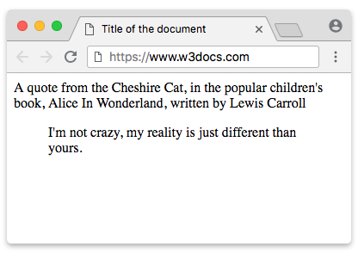

**5.4 - Horizontal Lines**

Horizontal lines, often called horizontal rules, can break up content or enhance visual appeal. Use the `<hr>` tag to insert a horizontal line. In HTML5, it's often used for thematic breaks at the paragraph level.

Example:

|  |  |  |  |
| --- | --- | --- | --- |
| Aspect | Description | Example | Outcome/Result |
| Start Tag | **<hr>** | **<hr>** | Inserts a horizontal line. |
| End Tag | None |  | No end tag required. |
| Attributes | None | None | No additional attributes needed. |
| Example | **<hr>** | Displays a horizontal line. | Separates content visually. |

**5.5 - Special Characters**

Sometimes, you need to display characters not readily available on a standard keyboard, like © or characters with special meanings in HTML (<, >, &, etc.). Use the Special Character Entity tag, which consists of an ampersand (&), followed by the code and a semicolon.

Example:

|  |  |  |
| --- | --- | --- |
| Description | Special Character | Character Code |
| Acute Accent | ´ | &#180; |
| Ampersand | & | &#38; |
| Cent Sign | ¢ | **&#162;** |
| Copyright | © | **&#169;** |
| Dagger | † | **&#8224;** |
| Degree Sign | ° | **&#186;** |
| Division Sign | ÷ | **&#247;** |
| Euro | € | **&#8363;** |
| Fraction (one-half) | ½ | **&#189;** |
| Fraction (one-fourth) | ¼ | **&#188;** |
| Fraction (three-fourths) | ¾ | **&#190;** |
| Greater-than sign | > | **&#62;** |
| Left-angle quote | « | **&#171;** |
| Less-than sign | < | **&#60;** |
| Multiply sign | x | **&#215;** |
| Plus or minus sign | ± | **&#177;** |
| Quotation Mark (left) | “ | **&#8220;** |
| Quotation Mark (right) | ” | **&#8221;** |
| Registered Trademark | ® | **&#174;** |
| Right-angle quote | » | **&#187;** |
| Superscript one | ¹ | **&#185;** |
| Trademark | ™ | **&#8482;** |

5.6 Actions

Now, let's summarize the actions you can take with these elements:

Adding a Heading:

1. Before the text you want as a heading, type `<h`.

2. Add the desired heading level (1 to 6).

3. Close the opening tag with `>`.

4. Enter your heading text.

5. After your text, type `</h` followed by the same heading level and `>`.

Adding Comments:

1. Go to the location in your HTML document where you want to add comments.

2. Type `<!--`.

3. Add your comments.

4. Type `-->`.

Adding Block Quotes:

1. Before the text you want as a block quote, type `<blockquote>`.

2. Enter your text.

3. After your text, type `</blockquote>`.

Adding a Horizontal Line:

1. To insert a horizontal line, type `<hr>`.

Adding Special Characters:

1. At the desired location in your text, type `&#`, followed by the character code, and then `;`.

Exercises

Purpose: To practice using headings, comments, block quotes, and special characters in your HTML document.

Exercises:

1. Open your existing HTML page.

2. Add a heading: `<h1>This is the largest heading.</h1>`.

3. Insert a comment: `<!-- Add photo here. -->`.

4. Create a block quote with a famous quote.

5. Add a horizontal line: `<hr>`.

6. Insert a paragraph with a special character, like the copyright sign: `<p>I can add special characters, like the copyright sign: &#169;</p>`.

7. Save your document.

By following these guidelines, you can enhance the professionalism and readability of your web content.

CHAPTER 6- Creating Lists

**Creating Lists**

In this section, we'll explore how to create different types of lists in HTML, including ordered (numbered) lists, unordered (bulleted) lists, nested lists, and definition lists. Lists are used to organize and present information in a structured way.

**6.1 - Numbered (Ordered) Lists:**

Numbered lists are used to display items in a specific order or sequence, often with a sense of priority. To create a numbered list:

1. Use `<ol>…</ol>` tags to enclose the list.

2. Use `<li>…</li>` tags for each list item.

3. Choose the list type (e.g., uppercase letters, lowercase letters) using the `type` attribute.

4. Start numbering at a specific point with the `start` attribute.

Example:

<ol type="A">

<li>First Item</li>

<li>Second Item</li>

<li>Third Item</li>

</ol>

Outcome: This creates a numbered list with items displayed as A. First Item, B. Second Item, C. Third Item.

**6.2 - Bulleted (Unordered) Lists:**

Bulleted lists are used when items don't need a specific order. To create a bulleted list:

1. Use `<ul>…</ul>` tags to enclose the list.

2. Use `<li>…</li>` tags for each list item.

3. Choose the bullet style (e.g., circle, square) using the `style` attribute.

Example:

<ul style="list-style-type:square">

<li>First Item</li>

<li>Second Item</li>

<li>Third Item</li>

</ul>

Outcome: This creates a bulleted list with square bullets for each item.

**6.3 - Nested Lists:**

Nested lists are numbered or bulleted lists contained within another list. To create nested lists:

1. Use `<ul>` or `<ol>` tags for the outer list.

2. Use `<li>` tags for each outer list item.

3. Insert another `<ul>` or `<ol>` for the inner list.

4. Use `<li>` tags for inner list items.

Example:

<ul>

<li>Outer List Item</li>

<li>Another Outer Item</li>

<ul style="list-style-type:circle">

<li>Nested Item 1</li>

<li>Nested Item 2</li>

</ul>

<li>Yet Another Outer Item</li>

</ul>

Outcome:This creates a nested list with items indented under "Another Outer Item."

**6.4 - Definition Lists:**

Definition lists display terms and their corresponding definitions. To create a definition list:

1. Use `<dl>…</dl>` tags to enclose the list.

2. Use `<dt>…</dt>` tags for each term.

3. Use `<dd>…</dd>` tags for each definition.

Example:

<dl>

<dt>Access</dt>

<dd>Create databases and programs to track and manage your information.</dd>

<dt>Excel</dt>

<dd>Perform calculations, analyze information, and manage lists in spreadsheets.</dd>

</dl>

Outcome: This creates a definition list with terms and their respective definitions.

Actions:

To create lists in HTML, follow these actions specific to each list type.

Exercises:

Practice creating an ordered list with the provided actions in your HTML document.

1. Open your existing HTML page.

2. After the last text in the body, add: `<p>`

3. Press "Enter."

4. Add: "This is an ordered list:"

5. Press "Enter."

6. Add: `<ol type="A">`

7. Press "Enter."

8. Add: `<li>First Item</li>`

9. Press "Enter."

10. Add: `<li>Second Item</li>`

11. Press "Enter."

12. Add: `<li>Third Item</li>`

13. Press "Enter."

14. Add: `</ol><p>`

15. Press "Enter."

16. Save your document.

By following these steps, you'll create an ordered list with uppercase letter labels.

CHAPTER 7- Links

**7.1 – What are Links?**

Understanding Hyperlinks

In HTML, one of its most dynamic features is the capability to create interactive hyperlinks, commonly referred to as "links." These links allow users to seamlessly navigate between web pages or resources. When a user clicks a link, it functions as a "jump" to the intended destination. Links can be applied to text or images and are typically displayed as underlined text. However, images can also serve as links. When users hover their mouse over a link, it typically transforms into a pointing hand icon, indicating its clickable nature.

Before creating links, it's vital to comprehend Uniform Resource Locators (URLs). Each web page on the internet has a unique address known as a URL (Uniform Resource Locator). To access a specific address, the HTTP (Hypertext Transmission Protocol) is commonly used, as seen in "http://www.example.com." For secure transactions, HTTPS (Hypertext Transmission Protocol, Secure) is employed, encrypting sensitive information like credit card data during e-commerce transactions. FTP (File Transfer Protocol) comes into play when physically transferring files to another computer, such as uploading web pages to a web server.

A standard web address consists of an HTTP prefix, a colon, and two forward slashes (http://). Typically, web browsers insert the HTTP prefix automatically while users surf the web. However, when including web addresses in your HTML code, it's essential to include it as part of the complete web address. The second part of a web address is the host name, which is preceded by "www." (for World Wide Web). The host name is also known as the domain. For example, in the web address "http://www.example.com," "example.com" is the host (domain) name. When linking to a page that isn't the site's main page, it's necessary to specify its precise location and file name. For instance, to direct someone to TeachUcomp, Inc.'s course selection page, the URL would be "http://www.teachucomp.com/." It's crucial to enter web addresses accurately, as a single incorrect character can result in a broken link. Always test your links before publishing your HTML page to ensure a positive user experience.

HTML offers two primary types of links: absolute and relative. Absolute links typically direct users to specific web pages outside the current website and include complete URLs (e.g., "http://www.example.com"). Conversely, relative links, often termed "shorthand web addresses," point to pages within the same website. For instance, within the TeachUcomp, Inc. website at "http://www.teachucomp.com/," a relative link to the course section might be "/courses/." When using a relative link, it's generally advisable to include a trailing slash (/). Omitting it may lead to your browser submitting a request to the server twice, first without the trailing slash and then with it automatically added by your browser.

**7.2 - Creating Text Links**

HTML employs anchor tags (<a>) to define links, using the <a href="..."> format. The "a" denotes an anchor tag, and the HREF attribute specifies the "Hyperlink Reference" or the action to be taken when users select the link. The <a href="..."> tag is followed by the text that users see and click on. Both the display text and the anchor tag are enclosed with the </a> end tag. An example of a typical text link is as follows: <a href="http://www.example.com">Home</a> . In this instance, users encounter the clickable text "Home," which, when clicked, directs them to the website www.example.com.

**7.3 - Creating Image Links**

In HTML, images can serve as clickable links, following a similar approach to text links. Instead of text, image code replaces the content that becomes the link.

**7.4 - Opening Links in New Windows or Tabs**

By default, HTML links open the linked page in the same browser window. However, there are cases when it's desirable to open the linked page in a new browser window or tab, especially when linking to external websites while retaining the current site. This practice ensures that users can access information from other sources without leaving your site. To open an individual link in a new browser window or tab, use the TARGET attribute with a value of "_blank" within the <a> start tag.

**7.5 - Setting All Links to Open in New Windows or Tabs**

In HTML, it's possible to configure all links on a webpage to open in new browser windows or tabs by adding <base target="_blank"> within the <head> section of the HTML document.

**7.6 - Linking to Sections on the Same Page (Bookmarks)**

In HTML, you can create links that direct users to specific sections on the same webpage, often referred to as "bookmarks." Bookmarks are particularly useful for lengthy pages or when you want to simplify navigation. To establish a bookmark link, follow a two-step process: first, identify and name the section you wish to link to. Enclose this section with anchor tags <a>...</a>. Within the <a> start tag, include an ID attribute with the chosen name. Second, create a link to the named section, but with a pound sign (#) preceding the anchor's name.

**7.7 - Linking to Email Addresses**

HTML allows you to create links that open users' default email editors with specified email addresses in the "To" field. To craft an email link, use the "mailto:" protocol followed by the email address. You can also pre-fill the email's subject line by appending "?subject=?" to the link, with spaces represented as "%20."

**7.8 - Linking to Other File Types**

HTML permits the creation of links to various file types beyond HTML, such as Microsoft Word documents or PDF files. Users must possess the appropriate software to open these files, and it's advisable to indicate the file type. When creating links to other file types, use the file name as the HREF value and ensure the file is uploaded to your server.

**7.9 - Linking to Address**

The <address> tag defines the contact information for the author/owner of a document or an article.

The contact information can be an email address, URL, physical address, phone number, social media handle, etc.

The text in the <address> element usually renders in italic, and browsers will always add a line break before and after the <address> element.

<address>  
Written by <a href="mailto:webmaster@example.com">Jon Doe</a>.<br>  
Visit us at:<br>  
Example.com<br>  
Box 564, Disneyland<br>  
USA  
</address>

**Action Links**

**Add a Text Link:**

1. To insert a text link, place the `<a href="?">` tag where you want the link.

2. Enter the text you wish to display as the link (e.g., "Home Page").

3. Close the link with the `</a>` tag.

HTML Example:

<a href="https://www.example.com">Visit Example.com</a>

**Add an Image Link:**

1. To create an image link, use the `<a href="?">` tag to define the link's destination.

2. Include the `<img src="?">` tag to specify the image you want to turn into a link.

3. Close the link with `</a>`.

HTML Example:

<a href="https://www.example.com">

<img src="image.jpg" alt="Image Link"> </a>

**Open a Page in a New Window:**

1. To create a link that opens in a new window or tab, use the `<a href="?">` tag to define the link's destination.

2. Add a space and `target="_blank"` within the tag.

3. Enter the text you want to display as the link.

4. Close the link with `</a>`.

HTML Example:

<a href="https://www.example.com" target="_blank">Visit Example.com</a>

Set All Links on a Page to Open in a New Window:

1. Inside the `<head>...</head>` section of your page, include `<base target="_blank">`.

**Link to an Area on the Same Page (Bookmarks):**

1. At the location on the page you want to link to, use `<a id="?"></a>` (replace "?" with your chosen anchor name).

2. Create the link to the anchor by using `<a href="#?"></a>` (where "#?" matches the anchor name).

HTML Example:

<a id="section1"></a>

<!-- ... content ... -->

<a href="#section1">Go to Section 1</a>

Link to an E-mail Address:

1. To add an e-mail link, use `<a href="mailto: ?">` (replace "?" with the recipient's e-mail address).

HTML Example:

<a href="mailto:info@example.com">Email Us</a>

Link to Other Types of Files:

1. To create a link to another file, use `<a href="?">` (replace "?" with the file's path and name).

HTML Example:

<a href="document.pdf">Download PDF</a>

These actions allow you to add various types of links to your webpages with appropriate HTML tags and attributes.

**Chapter 8 Images**

**8.1 - Understanding Images for Webpages**

Images serve as captivating elements for webpages, encompassing various forms such as photographs and graphics. Several file types are used for webpage images, with the most common ones being JPEG, GIF, and PNG. It's essential to grasp these file types and how browsers handle them.

- JPEG: Ideal for complex, detail-rich images like photographs.

- GIF: Suited for simpler, less-detailed graphics, logos, and short animations.

- PNG: Combines the 24-bit support of JPEG with advanced compression.

Apart from image quality, the download time is a crucial factor when adding images to webpages. Users' browsers download images when visiting a webpage, and more images or larger file sizes lead to slower page loading. Best practice recommends keeping individual image sizes below 100K. Page load time also depends on the user's connection speed.

**8.2 - Adding Images to Webpages**

To include an image in your webpage, employ the <img> tag and specify the file name using the SRC (source) attribute. The SRC attribute should contain the image's name, including the file extension. If the image is hosted on a different server, the full path to the image must be provided.

**Images in Another Folder**

If you have your images in a sub-folder, you must include the folder name in the src attribute:

Example

<img src="https://www.w3schools.com/images/w3schools_green.jpg" alt="W3Schools.com">

**Images on Another Server/Website**

Some web sites point to an image on another server.

To point to an image on another server, you must specify an absolute (full) URL in the src attribute:

Example

<img src="https://www.w3schools.com/images/w3schools_green.jpg" alt="W3Schools.com">

**HTML allows animated GIFs:**

Example

<img src="programming.gif" alt="ComputerMan" style="width:48px;height:48px;">

<area shape="rect" coords="left,top,right,bottom">

<area shape="rect" coords="x,y,x+width,y+hight">

<area shape="circle" coords="center x, center y, radius" title="Circle" href="https://google.com/">

</map>

# <h1>Click on a shape to see how it works:</h1>

# <img src="/examples/images/shapes.png" alt="Geometrical Shapes" usemap="#shapes">

# <map name="shapes">

# <area shape="circle" coords="40,40,40" href="/examples/html/circle.html" alt="Circle">

# <area shape="poly" coords="148,2,104,80,193,80" href="/examples/html/triangle.html" alt="Triangle">

# <area shape="rect" coords="226,2,323,80" href="/examples/html/rectangle.html" alt="Rectangle">

# <area shape="poly" coords="392,2,352,32,366,80,418,80,432,32" href="/examples/html/pentagon.html" alt="Pentagon">

# </map>

# Geometrical Shapes

**8.3 - Resizing an Image**

You can adjust the size of an image in your HTML page using the WIDTH and HEIGHT attributes. However, be cautious when resizing images via HTML coding, as improper dimensions can distort the image. You can specify dimensions in pixels or as a percentage of the browser window size.

**8.4 - Alternative Text**

Alternative text, also known as ALT text or placeholder text, serves two purposes. First, it provides a description of the image, aiding users who disable images for faster downloads. Second, some search engines use ALT text when indexing pages. To add alternative text to an image, insert the ALT attribute within the <img> tag.

**8.5 - Image Labels**

Image labels, also known as titles, display a tooltip when users hover their mouse pointer over an image. To implement this feature, use the TITLE attribute within the <img> tag.

**8.6 Image map**

The <map> tag is used to define an image map. An image map is an image with clickable areas.

The required name attribute of the <map> element is associated with the [<img>](https://www.w3schools.com/tags/tag_img.asp)'s usemap attribute and creates a relationship between the image and the map.

The <map> element contains a number of [<area>](https://www.w3schools.com/tags/tag_area.asp) elements, that defines the clickable areas in the image map.

<map>

<area shape="rect" coords="left,top,right,bottom">

<area shape="rect" coords="x,y,x+width,y+hight">

<area shape="circle" coords="center x, center y, radius" title="Circle" href="https://google.com/">

</map>

<img src="map.jpg">

You must define the shape of the clickable area, and you can choose one of these values: rect - defines a rectangular region. circle - defines a circular region. poly - defines a polygonal region.

**Example:** using map tag to make the following 3 shapes clickable.

<map name="imagemap">

<area shape="rect" coords="30,37,249,196" title="Rectangle" href="https://google.com/">

<area shape="circle" coords="479,123,65" title="Circle" href="https://google.com/">

<area shape="poly" coords="313,195,240,353,430,353" title="Triangle" href="https://google.com/">

</map>

<img src="map.jpg" usemap="#imagemap">

* **Find coordinates of image**

There are many tools available to find the coordinates of images, such as the ruler tool in Paint software on Windows operating systems, which is pre-installed, or using the Photoshop ruler tool to find coordinates. Additionally, many free online websites are available to provide coordinates for HTML map tags. For example, on the following website:

<https://www.programminghead.com/Projects/find-coordinates-of-image-online.html>

The following explanation will give you an idea of how to find the coordinates of an image using the above-mentioned website:

**How to get Rectangle Coordinates**

You just need to pick your Object from your Image just by clicking on the TOP-Left and BOTTOM-RIGHT edge of subject.

Right below your Selected IMAGE there is the first Section for Rectangle Coordinates. Where you can view your TOP-Left and BOTTOM-RIGHT coordinates for selected Object.

**How to get Circle Co-Ordinates**

You just need to pick your Object from your Image just by clicking on the Center (if it’s a Circular Object) to get the Position of your OBJECT and RIGHT edge of Object to get the Radius.

Right below your Selected IMAGE there is the 2nd Section for Circle Coordinates.

Where you can view the Position and Object Radius coordinates for selected Object.

**How to get Polygon Co-Ordinates**

You just need to pick your Object from your Image just by clicking on every edge of subject.

Right below your Selected IMAGE, Third Section for Rectangle Coordinates.

Where you can view your All the coordinates for selected Object.

**Image Actions**

**Adding an Image:**

<!DOCTYPE html>

<html>

<head>

<title>Add an Image Example</title>

</head>

<body>

<img src="image.jpg" alt="A beautiful landscape">

</body>

</html>

**Resizing an Image:**

<!DOCTYPE html>

<html>

<head>

<title>Resize Image Example</title>

</head>

<body>

<img src="image.jpg" width="300" height="200" alt="A resized image">

</body>

</html>

**Adding Alternative (ALT) Text:**

<!DOCTYPE html>

<html>

<head>

<title>Alternative Text Example</title>

</head>

<body>

<img src="image.jpg" alt="A descriptive alternative text">

</body>

</html>

**Adding an Image Label (TITLE):**

<!DOCTYPE html>

<html>

<head>

<title>Image Label Example</title>

</head>

<body>

<img src="image.jpg" title="Image with a label">

</body>

</html>